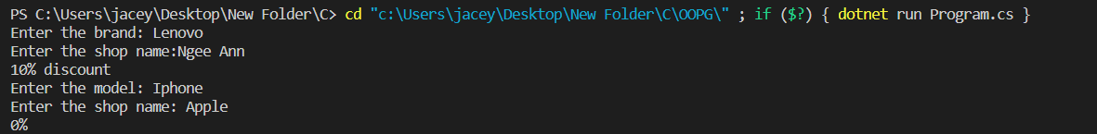

using System;

namespace OOPG_L8E1

{

    class ElectronicsShop

    {

        private string strShopName;

        public ElectronicsShop(string name)

        {

            strShopName = name;

        }

        public virtual string GetDiscount()

        {

            return "0%";

        }

    }

    class Computer : ElectronicsShop

    {

        private string strBrand;

        public Computer(string brand, string name) : base(name)

        {

            strBrand = brand;

        }

        public override string GetDiscount()

        {

            return "10% discount";

        }

    }

    class Phone : ElectronicsShop

    {

        private string strModel;

        public Phone(string model, string name) : base(name)

        {

            strModel = model;

        }

    }

    class Program

    {

        static void Main(string[] args)

        {

            Console.Write("Enter the brand: ");

            string brand = Console.ReadLine();

            Console.Write("Enter the shop name:");

            string shop = Console.ReadLine();

            Computer objCom = new Computer(brand, shop);

            Console.WriteLine(objCom.GetDiscount());

            Console.Write("Enter the model: ");

            string model = Console.ReadLine();

            Console.Write("Enter the shop name: ");

            shop = Console.ReadLine();

            Phone objPhone = new Phone(model, shop);

            Console.WriteLine(objPhone.GetDiscount());

        }

    }

}

using System;

namespace OOPG_L8E2

{

    class Picture

    {

        private string strTitle;

        private float fltPrice;

        public Picture(string title, float price)

        {

            strTitle = title;

            fltPrice = price;

        }

        public virtual float GetPrice() => fltPrice;

        public string Title => strTitle;

    }

    class Photograph : Picture

    {

        private string strPhotographer, strCamera;

        public string Photo => strPhotographer;

        public string Cam => strCamera;

        public Photograph(string photo, string cam, string title, float price) : base(title, price)

        {

            strPhotographer = photo;

            strCamera = cam;

        }

        public override float GetPrice()

        {

            return base.GetPrice() + 30;

        }

    }

    class Painting : Picture

    {

        private string strArtist, strType;

        public string Artist => strArtist;

        public string Type => strType;

        public Painting(string artist, string type, string title, float price) : base(title, price)

        {

            strArtist = artist;

            strType = type;

        }

        public override float GetPrice()

        {

            return base.GetPrice() + 50;

        }

    }

    class Program

    {

        static void Main(string[] args)

        {

            Console.Write("Enter photographer: ");

            string photo = Console.ReadLine();

            Console.Write("Enter camera type: ");

            string cam = Console.ReadLine();

            Console.Write("Enter the title of photograph: ");

            string title = Console.ReadLine();

            Console.Write("Enter the price of photograph: ");

            float price = float.Parse(Console.ReadLine());

            Photograph objPhoto = new Photograph(photo, cam, title, price);

            Console.WriteLine($"PHOTOGRAPHER: {objPhoto.Photo} \nCAMERA: {objPhoto.Cam} \nTITLE: {objPhoto.Title} \nPRICE: {objPhoto.GetPrice()}");

            Console.Write("\nEnter artist: ");

            string artist = Console.ReadLine();

            Console.Write("Enter type of painting: ");

            string type = Console.ReadLine();

            Console.Write("Enter the title of painting: ");

            title = Console.ReadLine();

            Console.Write("Enter the price of painting: ");

            price = float.Parse(Console.ReadLine());

            Painting objPainting = new Painting(artist, type, title, price);

            Console.WriteLine($"ARTIST: {objPainting.Artist} \nTYPE: {objPainting.Type} \nTITLE: {objPainting.Title} \nPRICE: {objPainting.GetPrice()}");

        }

    }

}